📄 Test Case: TC49_LodgetheOutwardBill
✅ PASSED:
[2026-02-10 14:05:58] Bill ID - 2222121214 Lodged successfully.
[2026-02-10 14:06:40] Bill ID - 2222121214 Lodged successfully.

📄 Test Case: TC50_AcceptTheOutwardbillWhichIsLodge
❌ FAILED:
[2026-02-10 14:07:26] Bill ID - 2222121214 Accepted successfully.
[2026-02-10 14:08:49] ❌ Error: Page did not load properly after action.
↳ Reason: ❌ Cannot invoke "String.trim()" because "VlabelText" is null

📸 Screenshot:
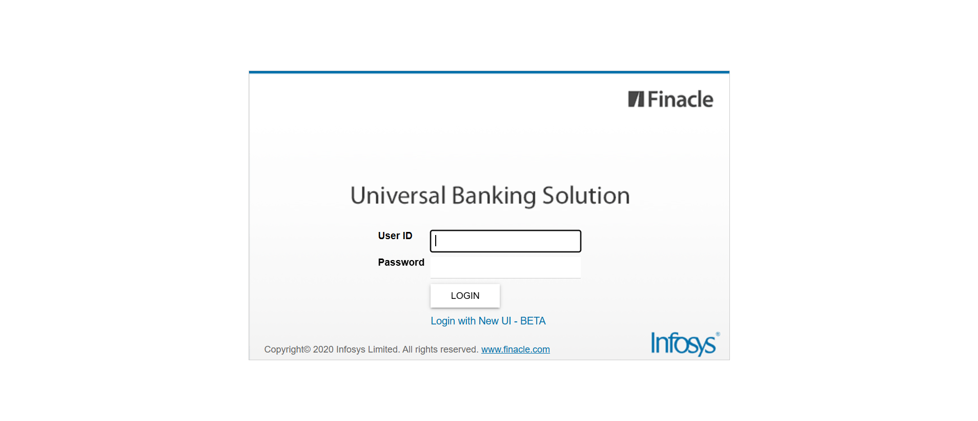
📄 Test Case: TC51_AmendTheOutwardBillWhichISAccepted
❌ FAILED:
[2026-02-10 14:09:46] ❌ Error: C22 - The previous process is not yet verified.
[2026-02-10 14:09:46] ❌ Assertion Failure: Test failed: C22 - The previous process is not yet verified.
↳ Reason: ❌ ❌ Assertion Failure: Test failed: C22 - The previous process is not yet verified.

📸 Screenshot:

📄 Test Case: TC52_FreeDeliveryOfOutwardBillWhichIsLodge
❌ FAILED:
[2026-02-10 14:10:32] ❌ Error: C22 - The previous process is not yet verified.
[2026-02-10 14:10:32] ❌ Assertion Failure: Test failed: C22 - The previous process is not yet verified.
↳ Reason: ❌ ❌ Assertion Failure: Test failed: C22 - The previous process is not yet verified.

📸 Screenshot:

📄 Test Case: TC53_ModifyTheOutwardBillAccountWhichIsFreedelivered
❌ FAILED:
[2026-02-10 14:11:17] ❌ Error: Charges Details
[2026-02-10 14:11:17] ❌ Assertion Failure: Test failed: Charges Details
↳ Reason: ❌ ❌ Assertion Failure: Test failed: Charges Details

📸 Screenshot:

📄 Test Case: TC54_InquiretheExportbillWhichIsModified
✅ PASSED:
[2026-02-10 14:11:52] ✅ Documentary Credit No: 2222121214
[2026-02-10 14:11:52] ✅ Inquired Successfully – Import No: 2222121214
[2026-02-10 14:11:52] ✅ AppData captured at inquiry time:
[2026-02-10 14:11:52] docStatus = Clean
[2026-02-10 14:11:52] LABELTEXT_BILLID = 2222121214
[2026-02-10 14:11:52] boeAmt = 1000.00
[2026-02-10 14:11:52] billCountry = 03
[2026-02-10 14:11:52] billType = IBCUL
[2026-02-10 14:11:52] billId = 2222121214
[2026-02-10 14:11:52] carrierCode = 001
[2026-02-10 14:11:52] LabelText = Inquired Successfully – Import No: 2222121214
[2026-02-10 14:11:52] sAccName = RAM
[2026-02-10 14:11:52] sAddr1 = OOTY
[2026-02-10 14:11:52] invoiceAmt = 1000.00

📄 Test Case: TC55_CancellingTheAccountWhichIsModifiedExportBill
✅ PASSED:
[2026-02-10 14:12:20] ❌ TEST FAILED | Expected E4221 but no error was thrown.
[2026-02-10 14:12:20] ✅ EXPECTED BUSINESS ERROR RECEIVED – TEST PASSED : E4221 – Nothing to Cancel

📄 Test Case: TC56_DelinkTheLodgeOutwardBill
✅ PASSED:
[2026-02-10 14:12:48] ❌ TEST FAILED | Expected E3494 but no error was thrown.
[2026-02-10 14:12:48] ✅ EXPECTED BUSINESS ERROR RECEIVED – TEST PASSED : E3494 – The bill is not purchasable

📄 Test Case: TC57_ProtestTheExportBillWhichIsInquired
✅ PASSED:
[2026-02-10 14:13:18] ❌ TEST FAILED | Expected E4221 but no error was thrown.
[2026-02-10 14:13:18] ✅ EXPECTED BUSINESS ERROR RECEIVED – TEST PASSED : E4221 – Bill should have been dishonoured

📄 Test Case: TC58_CloseTHeOutwardBillWhichIsLodge
❌ FAILED:
[2026-02-10 14:13:43] ❌ Exception Occurred: unexpected alert open: {Alert text : Are you sure you want to logout?}
(Session info: MicrosoftEdge=144.0.3719.115): Are you sure you want to logout?
Build info: version: '4.38.0', revision: '6b412e825c*'
System info: os.name: 'Windows 11', os.arch: 'amd64', os.version: '10.0', java.version: '17.0.16'
Driver info: org.openqa.selenium.edge.EdgeDriver
Command: [5fd38adeb0525d0cf50535e018d5c15e, findElement {value=menuSelect, using=id}]
Capabilities {acceptInsecureCerts: false, browserName: MicrosoftEdge, browserVersion: 144.0.3719.115, fedcm:accounts: true, goog:processID: 11844, ms:edgeOptions: {debuggerAddress: localhost:55681}, msedge: {msedgedriverVersion: 144.0.3719.115 (4ee501a4f64..., userDataDir: C:\Users\PRIYAR~1\AppData\L...}, networkConnectionEnabled: false, pageLoadStrategy: normal, platformName: windows, proxy: Proxy(), se:cdp: ws://localhost:55681/devtoo..., se:cdpVersion: 144.0.3719.115, setWindowRect: true, strictFileInteractability: false, timeouts: {implicit: 0, pageLoad: 300000, script: 30000}, unhandledPromptBehavior: dismiss and notify, webauthn:extension:credBlob: true, webauthn:extension:largeBlob: true, webauthn:extension:minPinLength: true, webauthn:extension:prf: true, webauthn:virtualAuthenticators: true}
Session ID: 5fd38adeb0525d0cf50535e018d5c15e
↳ Reason: ❌ ❌ Exception Occurred: unexpected alert open: {Alert text : Are you sure you want to logout?}
(Session info: MicrosoftEdge=144.0.3719.115): Are you sure you want to logout?
Build info: version: '4.38.0', revision: '6b412e825c*'
System info: os.name: 'Windows 11', os.arch: 'amd64', os.version: '10.0', java.version: '17.0.16'
Driver info: org.openqa.selenium.edge.EdgeDriver
Command: [5fd38adeb0525d0cf50535e018d5c15e, findElement {value=menuSelect, using=id}]
Capabilities {acceptInsecureCerts: false, browserName: MicrosoftEdge, browserVersion: 144.0.3719.115, fedcm:accounts: true, goog:processID: 11844, ms:edgeOptions: {debuggerAddress: localhost:55681}, msedge: {msedgedriverVersion: 144.0.3719.115 (4ee501a4f64..., userDataDir: C:\Users\PRIYAR~1\AppData\L...}, networkConnectionEnabled: false, pageLoadStrategy: normal, platformName: windows, proxy: Proxy(), se:cdp: ws://localhost:55681/devtoo..., se:cdpVersion: 144.0.3719.115, setWindowRect: true, strictFileInteractability: false, timeouts: {implicit: 0, pageLoad: 300000, script: 30000}, unhandledPromptBehavior: dismiss and notify, webauthn:extension:credBlob: true, webauthn:extension:largeBlob: true, webauthn:extension:minPinLength: true, webauthn:extension:prf: true, webauthn:virtualAuthenticators: true}
Session ID: 5fd38adeb0525d0cf50535e018d5c15e

📸 Screenshot:

============================================================
📊 Suite Summary: Test
===============================================
Test
Total tests run: 10, Passes: 5, Failures: 5, Skips: 0
===============================================
⏱️ Total Duration: 08 min 33 sec

